 

**FINAL REPORT**

**BAQLBAQLCRAFT By**

**Zhasylanuly Muslim & Kairatov Batyrkhan**

A report submitted in partial fulfillment of the requirements for the Programming Discipline

at Nazarbayev Intellectual School

**Supervised by Ms. Agis Iskaziyeva**

**Grade____________**

**Date____________**

**Sign____________**

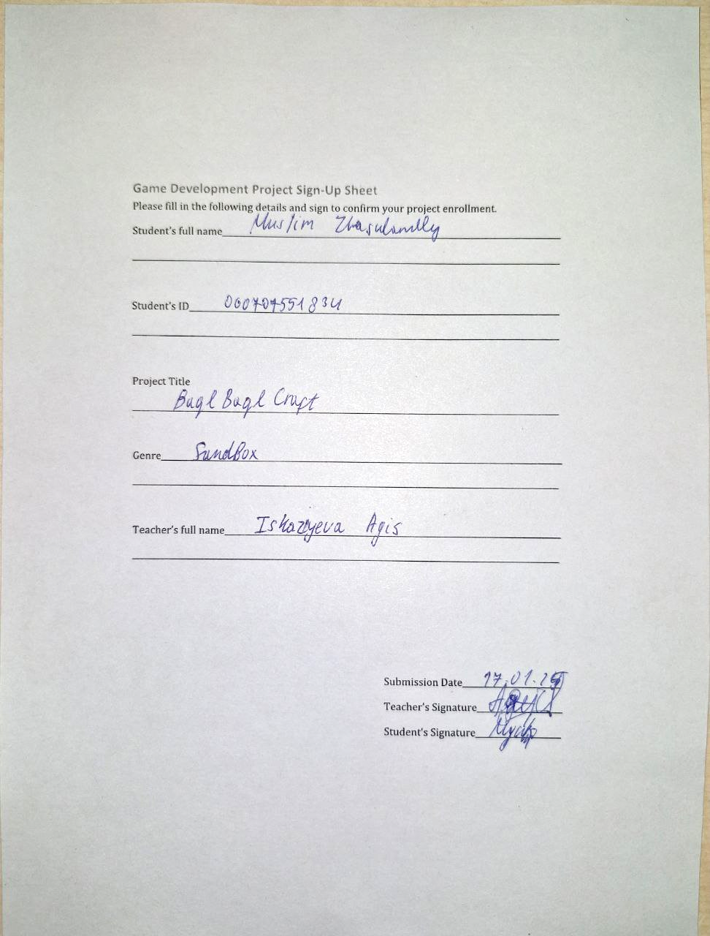

# Table of Contents

Table of Contents 1

Table of Figures 2

1. GAME CONCEPT DOCUMENT (GCD) 3

1.1 Game Title 3

1.2 Genre 3

1.3 Concept Overview 3

1.4 Target Audience 3

1.5 Initial Sketches (characters, levels) 3

2. GAME DESIGN DOCUMENT (GDD) 4

2.1 Game Overview 4

2.2 Gameplay Mechanics 4

2.3 Level Design 4

2.4 Characters and Objects (descriptions, roles) 4

2.5 Wireframes of Screens 4

2.6 Controls Plan 4

3. DEVELOPMENT DOCUMENTATION 5

3.1 Development Environment Setup 5

3.2 Key Libraries Used (e.g., PyGame, PIL, Wave) 5

3.3 Implementation Details: 5

3.4 Code Snippets 5

4. TESTING AND DEBUGGING LOGS 6

4.1 Testing Scenarios 6

4.2 Bugs Found and Solutions 6

4.3 Feedback and Adjustments 6

5. PRESENTATION MATERIALS 7

5.1 Startup Pitch Outline 7

5.2 Game Demo and Features 7

5.3 Future Development Plans 7

# Table of Figures

# 1. GAME CONCEPT DOCUMENT (GCD)

## Game Title

BaqlBaqlCraft

## Genre

Sandbox

## Concept Overview

BaqlBaqlCraft is a creative sandbox game inspired by the mechanics and world-building aspects of Minecraft but developed using Python. Players can explore, mine, craft, and build within an expansive procedural world, offering both survival and creative modes.

## Target Audience

BaqlBaqlCraft is designed for players of all ages who enjoy open-world exploration, creativity, and problem-solving. It is particularly aimed at fans of sandbox games, Python enthusiasts, and players who enjoy games with a mix of construction, resource management, and adventure.

## Initial Sketches (characters, levels)

Antagonist: MC Sailaubek

Protagonist: Bayzhan

Additional characters: Zombies, Timur, Miras, Michael Jackson, “P.Diddy”.

# 2. GAME DESIGN DOCUMENT (GDD)

## Game Overview

This game doesn’t have a deep plot, but has entertaining sandbox gameplay, that will allow players to express their creativity by building new things or creating their own story. Various enemies will make this adventure much harder.

## Gameplay Mechanics

Breaking blocks, placing blocks, attacking enemies, running, walking.

## Level Design

Procedural map that will be random at every new beginning

## Characters and Objects (descriptions, roles)

Characters:

Bayzhan. Just the main character who can punch, walk, run, craft, build.

Zombies. Hostile creatures who will appear at nighttime and try to kill Bayzhan.

P.Diddy. The main boss of the game. Will drop baby oil after defeat.

Miras. The hardest enemy of the game. He has many HP and defense because of his fat. Will drop KFC or McDonalds’ food.

Timur. The homeless man. Will trade things for food.

Michael Jackson. The only user of secret technique “Hee-Hee”. Will teach new secret techniques after leveling.

Objects:

Dirt block

Grass block 

Tree block 

Leaves block

Stone

## Wireframes of Screens

## Controls Plan

WASD for movement.

Mouse -Camera movement.

Right click - block placement.

Left click – block destruction.

Spacebar – Jump.

Q-Exit.

# 3. DEVELOPMENT DOCUMENTATION

## Development Environment Setup

## Key Libraries Used (e.g., PyGame, PIL, Wave)

Ursina

## Implementation Details:

Game Window and Loop

Core Mechanics (movement, collision, animation)

Advanced Features (sound, text, effects)

## Code Snippets

# 4. TESTING AND DEBUGGING LOGS

## Testing Scenarios

## Bugs Found and Solutions

## Feedback and Adjustments

# 5. PRESENTATION MATERIALS

## Startup Pitch Outline

## Game Demo and Features

## Future Development Plans